Project Design Phase

Solution Architecture

Date | 20 February 2026
Team ID | LTVIP2026TMIDS70508
Project Name | Learn Hub : Your Center for Skill Enhancement
Maximum Marks | 4 Marks

Solution Architecture:
Solution architecture is a structured process that bridges business requirements and technology implementation. It defines how the Learn Hub platform components interact to deliver an efficient and scalable online learning system. Its goals are to:
• Find the best technical solution to solve online learning accessibility problems.
• Describe the structure, behavior, and characteristics of the MERN-based system.
• Define features such as authentication, course management, progress tracking, and certification.
• Provide specifications for development, deployment, and maintenance of the solution.

Example - Solution Architecture Diagram:
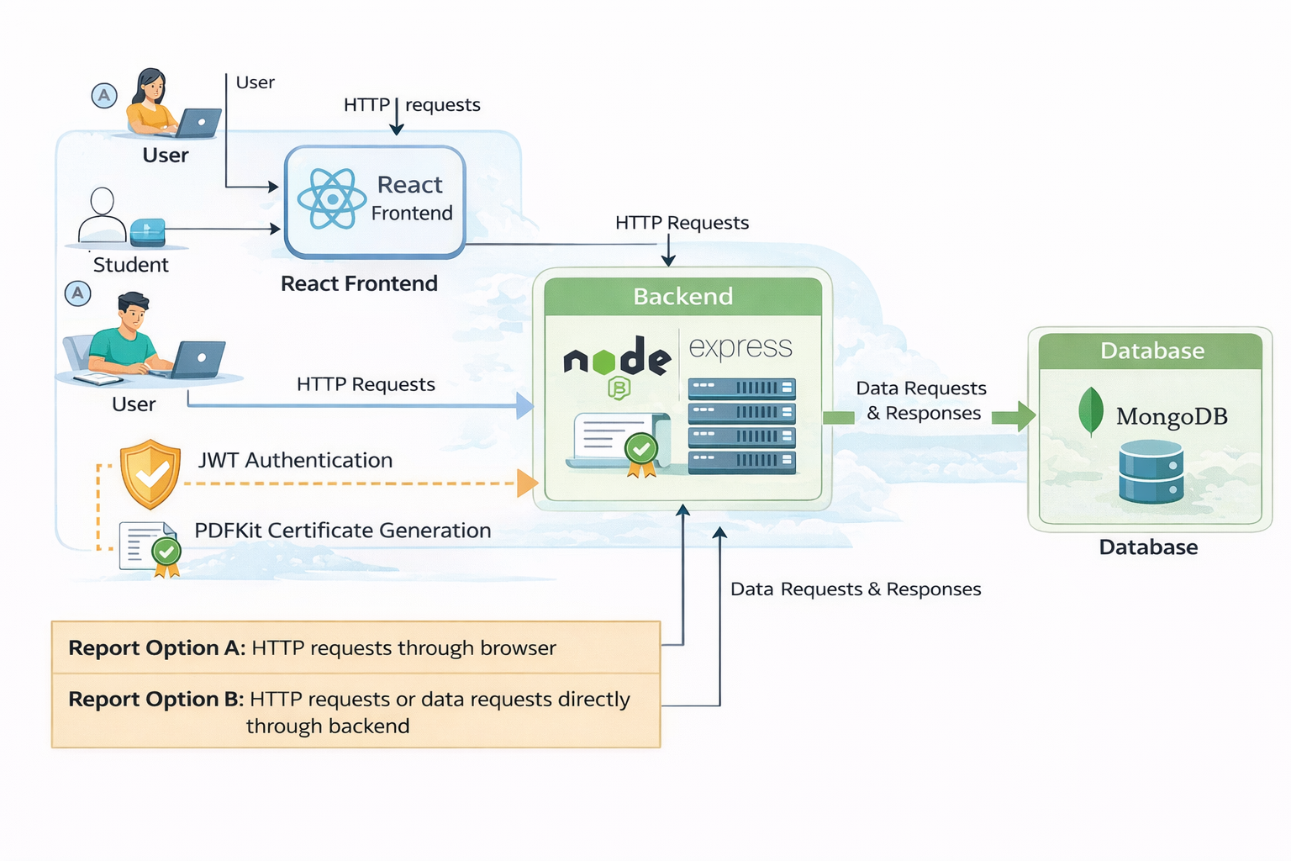
Figure 1: Architecture and data flow of the Learn Hub online learning platform
Reference: Internal MERN Architecture Design

